7th Tradition- $47.00
Intergroup reps present: 27
Intergroup Meeting Minutes
December 8, 2025
Join Online Meeting
https://zoom.us/j/95812571807?pwd=Z3hLaW5NK2Z4ZVVITDBrMU5OeThtQT09
Meeting ID: 958 1257 1807
Passcode: 710AA
Reports
Central Office Manager: Eileen P.
Things are running smoothly in the office.
Monthly (daytime) Hotline Totals are as follows:
Approximately 210 calls for the month of November.
Most of the calls were for meetings and/or literature information; the rest were regarding AA events, 12-step calls, or office questions.
When submitting Meeting Contributions, please include the Meeting Name and an email address so we can thank your group and send a receipt if requested.
Openings for in-office daytime hotline volunteers are:
Tuesday: 12 Noon -4 PM
Thursday: 8 AM – 12 Noon
Friday: 8 AM- 12 Noon (x2)
Saturday: 9-Noon & Noon-3

Board of Directors Treasurer: Maureen for Mike S.
Even though your Central Office was closed for the last three business days of November for Thanksgiving Day and the RoundUp, our year-to-date financials remain stable and healthy.
Year-to-date, we are meeting our budget expectations for anticipated contributions and our expense requirements.
We thank our groups and individuals who continually submit their contributions on a recurring basis, as well as, those who use our electronic services, especially Zelle. As we come to the end of another calendar year, we also acknowledge the above-expected results of Central Office's fundraising events, Founder's Day and the Gratitude Ball. And we are grateful for the numerous special events held, who submit wonderful contributions. It is because of the fellowship's efforts and generosity that make your Central Office a viable organization.
Thanks for allowing me to be of service in this capacity for the last two years. It's been an amazing experience and privilege.
Mike S.

12 Step List: Shawn M.
We have a few new add-ons to the list in November, and we are looking forward to participating at the Service Festival to get the word out about the 12 Step List, along with some small prizes for people that want to sign up.

Accessibility and Meetings to Go Chair: Diana M..
The Southern Area 42 Accessibilities Committee actively identifies, helps to raise awareness, and works to remove different types of obstacles—whether related to location, language, physical movement, or information processing—so that all members can participate equally in AA activities.
Please scan the QR codes below to access the following documents:
- To ensure all members, including those with visible and non-visible challenges, feel welcome and safe, meetings can implement practical accessibility measures such as enabling closed captioning for virtual meetings, using screen-reader-friendly document formats, and ensuring in-person locations are accessible with designated space for various needs. The document, “Best Practices to Make and Keep Our Meetings Accessible” also highlights respectful communication using people-first or identity-first language as preferred by individuals and suggests updating meeting listings with universal accessibility symbols.
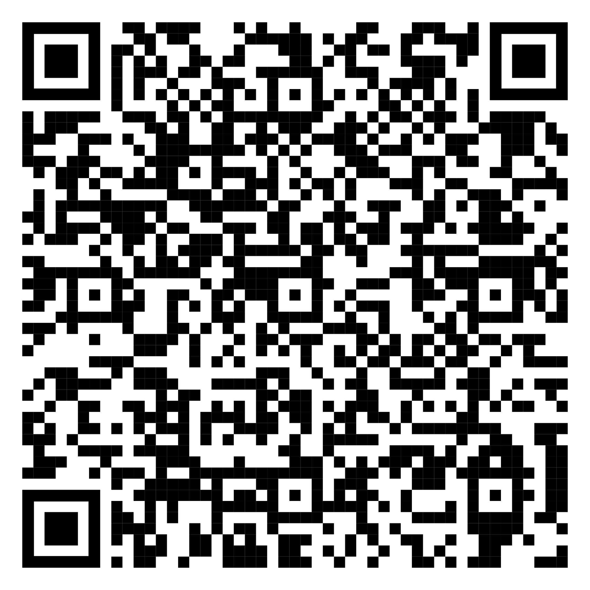
BEST PRACTICES
- An estimated 20% of people have difficulty reading documents printed in "serif" fonts, which are common in current AA literature. To assist and improve accessibility for AA members who have low vision, use screen readers, have reading issues, and cognitive or intellectual processing challenges, “How to Produce an Accessible Document” suggests simple methods to make the message of AA available to more alcoholics.
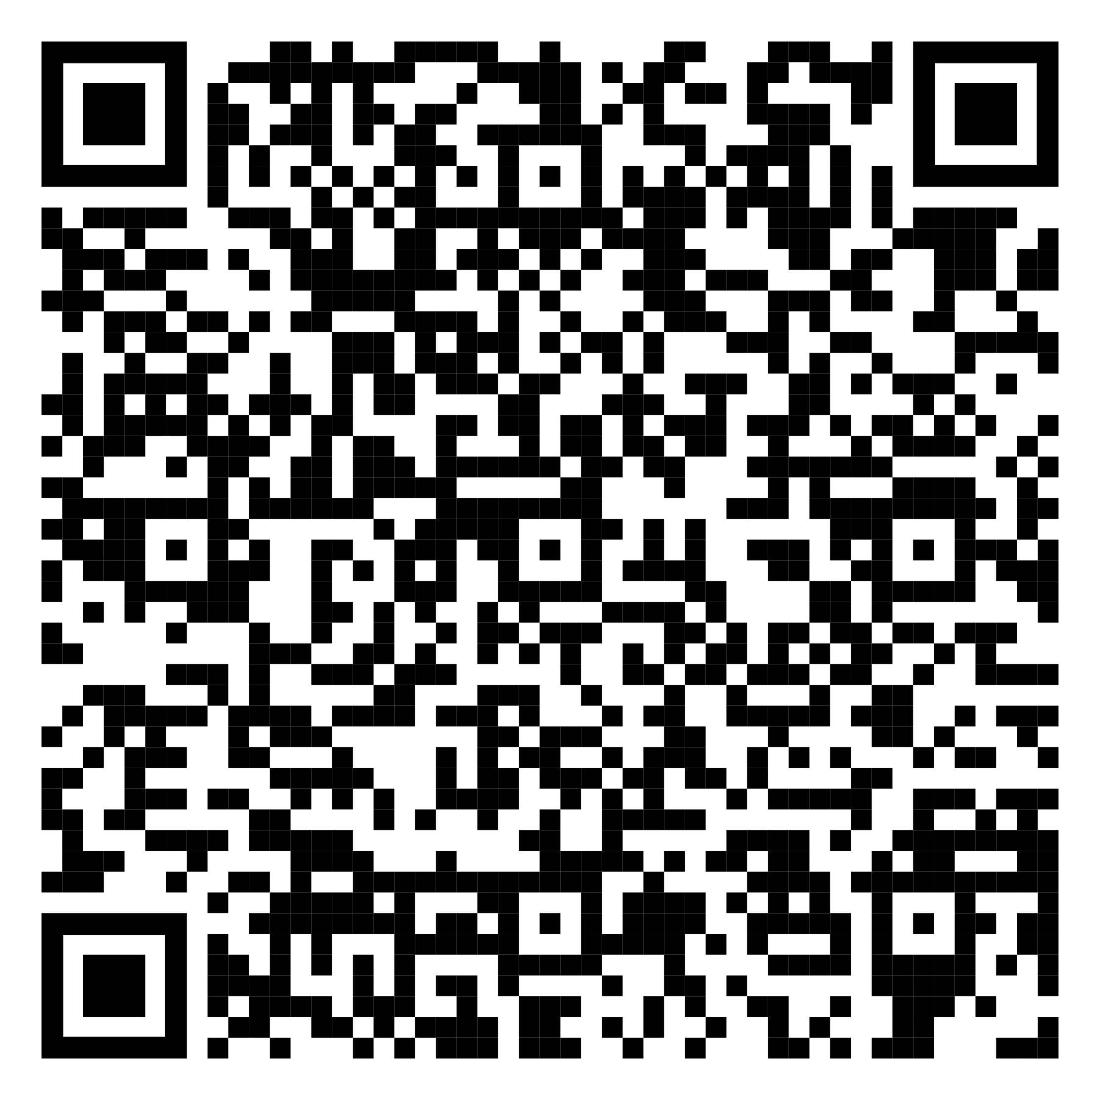
ACCESSIBLE DOCUMENT
News: This committee is organizing a first-ever workshop aimed to help the wider fellowship open the conversation about accessibility within A.A., focusing on the barriers some members face in participating fully in meetings, events, service commitments, and fellowship. This workshop will feature members from a wide range of backgrounds and with diverse experiences. The goal is awareness and education, rooted in our shared primary purpose to ensure that the message of A.A. is available to every alcoholic who seeks it, regardless of their circumstances. I will be following up with more information very soon.

Join us! The committee meets online every fourth Monday at 7:00 p.m. on the Zoom platform. We have members who speak English and Spanish. Our next meeting is on December 22, 2025. The meeting ID is 833 0643 2783. Password: handofaa.

I present this report with a grateful heart and in loving service.

Contact: sagscaccessibility@nevadaarea42.org or dianaserviceA42@google.com

Archivist: Heather L.
Archives really enjoyed sharing some AA history, the Area 42 timeline, artifacts, and collections with members at the 59th Las Vegas Roundup. We look forward to taking part in the Annual Service Festival on December 14th right here at Central Office. It looks to be loads of fun, with an amazing speaker, trivia, and bingo! We love seeing volunteers at our (2) monthly meetings each month. Typically, our virtual meeting is on the third Saturday and the live meeting is at Central Office on the last Thursday of the month. However, due to Christmas please take note of this month's special meeting dates/times below:

12/18 - Archives live mtg at Central Office @ 10am (moved because the last Th. is Christmas)
12/20 - Area 42 Archives Mtg @ 10:30 on zoom (MEETING ID: 867 1631 4717, PASSCODE: Archives42)
Heather L. - SAGSC Archives, Area 42 Alt Archivist

Board of Directors Chair: Greg for David G.
We meet once a month to discuss the budget, expenses and policies. Two of the nine Board members will be rotating out at the end of the year. We have reviewed six applicants and elected Eric J. and Steve N. as our newest Board members. They will begin their term in January 2026. Our next meeting will be held on Monday, December 15 and we will nominate and vote in a new Chair, who will begin their term in January 2026. We had a table at the Las Vegas Round Up, and sold a good amount of literature.
Cooperation with the Professional Community /CPC Chair:-No report

General Service/Intergroup Liaison: Shawn F.
The Service Festival will be held on Sunday, December 14th from 1pm to 4pm. Our past delegate, Jake S., will be the speaker and answer questions. We will also have refreshments, events, and we will be celebrating all of those who are in service to be there for the still suffering alcoholic. Please join us, check out the committees and see where you can help!!! Thank you for your support.

Grapevine Committee Chair: Ruthie B.
Wishing you warm greetings from your Southern Area Grapevine. All of us at Team GV are grateful for the opportunity to have served the Fellowship over the past year. We extend best wishes for the Holiday Season and the New Year as we work together in the Fellowship of the Spirit, one day at a time. If you are rotating into this service position, welcome. We meet the last Tuesday of each month @ 7pm on Zoom: 863 7191 9329
Passcode: Grapevine

A few highlights from this year:
For those who attended our writing workshop, thank you for your support, we had so much fun sharing the history of our beloved GV with you all in our fun skit. The mindful portion of the workshop was amazing, I hope you will continue with your personal practice and stay connected to your HP and feel encouraged and hopeful. For those who submitted stories, thank you for your participation, there is still time to submit stories, SUBMIT WORK: gveditorial@aagrapevine.org. If your work is fairly short, the simplest way to submit it is within the body of your email. However, if you do wish to attach a file to your email, please save the document in word or simple text format.
In 2024, Grapevine/ celebrated its 80th anniversary. Our meeting in print has been helping, newcomers, connect, and long timer stay connected, for all of those 80 years, bringing personal stories, written by members with diverse experiences. Our book, “Living Sober” celebrated 50 years, we are grateful for the “Little Yellow book” and the key phrases included, learning to accept what you cannot change, managing anger through healthy actions, and realizing that "acceptance is the answer to all my problems today". AA, Grapevine continues to be a lifeline for so many alcoholics. This year we have celebrated 90 years of Alcoholics Anonymous at the 2025 international convention. This summer people came from all over the world to celebrate together in Vancouver, BC the release from that hopeless state of mind and body and the joy found in helping others. The gift of sobriety shared together with friends is something we can continue to do this holiday season.
Gift Ideas & Promotions:
Please consider a gift subscription for your group or sponsee. (It’s only $2.99/ month) Now is the perfect time to order a gift or something for yourself.
Enjoy FREE SHIPPING on all Grapevine products!
This fantastic offer is available from November 1 to December 31.
Don’t miss out, visit us at www.aagrapevine.org/store to learn more!
Join us every Monday on our lively AA, Grapevine/ podcast, featuring great interviews, jokes, and AA News. It’s free and lots of fun. Look for it wherever you get podcasts. Follow us on Instagram at alcoholicsanonymous._gv.
Magazine December: Remedy for a Lonely Holiday

Holidays are time for fun, fellowship, joy, and laughter. But they can also be stressful and lonely. Thanks to AA, we have great tools to help us navigate the month of December. These stories will help us stay connected and keep in mind those who can’t reach us and panicked newcomers can feel connected.

Here’s to a peaceful, joyful, sober holiday season!
Your Friend in Service,
Ruthie B
SAGSC GV Chair

Gratitude Ball Chair: Roxanne N. – No report

Hispanic Central Office: Jose B.- No report

Hospitals & Institutions Chair: Dave S.- No report
Hotline Chair: Jim Sowatzki- No report

Las Vegas Round-Up Chair: Greg for Emmie M.
The Las Vegas Round up was a success, the 7th Tradition from the marathon meetings contributed $1,600 to Central Office. Emmie, the Chairperson, will be rotating out and our new Chairperson will be Tammy W.

Outreach Committee / Unity Chair: Bryan F.
The purpose of the Unity Committee is to help our members understand how we can carry the message to the still suffering and newcomer alcoholics.
Our Unity Committee has been invited to the upcoming Service festival being held this month at our Central Office. This promises to be a great event and I am looking forward to the opportunity to speak with a number of our members looking for some of the many different ways that we can carry the message.
In January, Districts 3, and 9, and 21, and 22 have all come together to create a Unity Workshop.
I cannot truly express how excited I am to work with all these Districts to promote the highlights of AA service in our community as well as nationally and potentially globally.
Yes our small and tiny voice, when magnified by so many members unified carry a message of strength and hope that is carried around the world.
I look forward to seeing and speaking with so many of you at these upcoming events.
And please, if you feel there is a need for your group or District to learn more about our Unity Committee, the service available and how the AA message can be heard, please reach out to me, any time.
My phone/text # is: (702)503-9601 -E-mail: bryanlfidler@gmail.com
Thank you for giving me the opportunity to be of service.
.......Bryan.......

Public Information Chair: John L.- No report

Silver Streak (SLVRSTRK): Katherine Z.
The committee is working hard to get the last issue of the year published in a timely manner. We have recently met to solidify our individual roles and recommit to timelines.
Please continue to send us your updates, events and announcements at slvrstrklv@gmail.com.
We are also looking for 30 Day Reflections and Sober+Time contributors.
In addition, we would love to invite anyone interested to join us at our monthly meeting!
We meet the first Monday of the month at 7:30pm via Zoom.
https://us05web.zoom.us/j/87545935270?pwd=sZqATsH4G1hO40nDPrWQaakaCH4zm3.1
Meeting ID: 875 4593 5270
Passcode: 1Et9PF
As always, please feel free to reach out to me directly:
Kat Z - 702.426.8985 - Katherine.zagajeski@gmail.com

Old Business: None

New Business: None

Best Practices to Make and Keep Our Meetings Accessible
Area 42 Accessibilities Committee
Email: sagscaccessibility@nevadaarea42.org or nagscaccessibility@nevadaarea42.org
AA Traditions remind us to carry the message to all Alcoholics and that the only requirement for membership is a desire to stop drinking. However, attending a meeting may be challenging for members with accessibility needs—some of which are not immediately visible. To ensure every member feels safe and welcome, here are practical ways to create an accessible meeting environment.
Virtual/Online Meetings:
- Remember to enable closed captioning for all virtual/online meetings. State that captioning is
enabled in your meeting format.
- Notify your Central Office that your meeting is closed captioned so your meeting listing can be updated with the universal symbol “CC”.
- In your meeting format, remind members who move or walk around during the meeting to turn off their cameras to avoid distractions for individuals with certain sensory sensitivities.
- When a deaf member shares/speaks, spotlight them, not the ASL interpreter. The ASL interpreter should be identified and pinned. In Nevada, ASL registered interpreters are required to follow a code of professional conduct which includes confidentiality and are welcome at both open and closed meetings even if they are not alcoholics. Registered Interpreters Code of Ethics
Handouts/Emails/Newsletters:
Members with low vision and with certain learning and intellectual processing challenges may use screen readers. Ensure your documents are prepared and written in a way that accommodates their needs.
- Use a white background for written materials like emails, slides, documents, and flyers.
- Always select a “Sans Serif” (without tails) font like Calibri or Arial. Avoid Serif fonts like Times New
Roman and novelty fonts.
- If you do a lot of document preparation, consider enabling the accessibility tools under “Document
Review” in Microsoft Word. This will offer suggestions for font colors, styles and layouts that are accessible as well as it does for spelling and grammar.
In-Person Meeting Environment:
- Designate an area with adequate space for a wheelchair or mobility device, for members who are
Deaf, Hard-of-Hearing, or for other conditions that may require certain accommodations.
- Appoint someone to greet members. Direct them to a seating area as needed, show the location of
the restroom, coffee, or other amenities.
- Update Meeting Listing. A meeting is considered fully wheelchair accessible if it has BOTH a ramp and accessible restroom. If a restroom is unavailable, the meeting should be noted as partially accessible. Please notify your wheelchair accessibility to your Central Office so your meeting listing can be updated with universal symbols.
- Respectful Communication and Consideration. People-first language is recommended by many US based organizations promoting a view of the individual as more than their condition. Some examples: “members with disabilities” or “members with diverse abilities”. Conversely, identity-first language is preferred by those who view their experience and identity as integral to who they are. For example: “Neurodivergent members”, “Deaf members”. Treat members with the same respect and consideration you would expect for yourself. If you're unsure of their needs, simply ask.
Who is MISSING in the rooms and why?
BEST PRACTICES _ ACCESSIBILITIES EN
How to Produce an Accessible Document (flyer, email, newsletters, handouts, etc.). Area 42 Accessibilities Committee
Email: sagscaccessibility@nevadaarea42.org or nagscaccessibility@nevadaarea42.org
Accessible printed documents and communications are defined under the Americans with Disabilities Act (ADA), Section 508 (United States) and under the Accessible Canada Regulations (Canada).
Currently, AA literature is produced in a variety of formats, many of which are not readable by AA members. Production of documents (such as pamphlets, checklists, literature, and even emails) in an accessible format assists AA members who have low vision, use screen readers, have reading issues and intellectual processing challenges. These members’ ability to read is greatly affected by how documents and visual aids are prepared and written.
For example, it is estimated that as much as 20% of the population is unable to read a document printed in a “Serif” font such as Times New Roman. Many AA documents and most literature (including the Big Book and 12&12) are printed in a “Serif” font, making it difficult for many alcoholics to read them smoothly or at all. Adopting a uniform appearance, color, and printing standard for all printed AA documents as they are reprinted, revised or developed for AA members provides a simple method to make the message of AA available to more alcoholics.
Producing an accessible document (flyer, email, newsletters, handouts, slides, etc.):
1. Software. Use software that includes an “Accessibility Checker” to produce the document. All Microsoft products (e.g. Microsoft Word, Outlook, Publisher, PowerPoint) and most Adobe products can easily check the document for readability using their built-in checker.
2. Format of the final document. Your finished document should remain in its original editable format (like Microsoft Word or Publisher) or be saved in a PDF format. Do not use JPG or TIF formats.
o Flyers. Using bright colors and novelty fonts for flyers helps attract attention but may affect their accessibility. Produce flyers as two-sided or two pages with the second page in an accessible format and the first in the graphics you choose.
3. Tips for Accessibility:
a. Use a white or light-colored background for written materials like emails, slides, documents and flyers particularly those that will be printed. For electronic documents, ensure that they are compatible with “dark mode” or High Contrast for members using a screen reader. Provide the original document at the start of the presentation to assist those who prefer high contrast or magnification.
b. Always select a “Sans Serif” (without tails) font like Aptos, Calibri, or Arial. Avoid “Serif” fonts like Times New Roman and novelty fonts (novelty fonts).
c. Avoid shading letters and images.
d. When producing printed materials, use an 11-point font or larger.
4. Check for Accessibility.
Before finalizing your document (or saving it as a PDF), check it for Accessibility. The checker will “point out” fonts, colors and shading that affect the readability of the document AND suggest better options.
- Microsoft Accessibility Checker https://support.microsoft.com/en-us/office/improve-accessibility with-the-accessibility-checker-a16f6de0-2f39-4a2b-8bd8-5ad801426c7f
- Adobe Accessibility Checker https://www.adobe.com/help/accessibility.html
- Google Docs Accessibility Checker.
https://workspace.google.com/marketplace/app/accessibility_checker_for_docs/4525299362 40
If you need help with your flyer or document, contact the Southern or Northern Area 42 Accessibilities Committee

